Deliverable III

**Process Models and Revised Use Cases**

**Gym Modernization**

_____________________________________ By: ___________________________________

Alek Babeki

Daniel Cunningham

Jay Early  
Tom Irwin  
Akram Khan

Pratik (PK) Padhiyar

# 

# Section II - Process Models

**Context Diagram:**

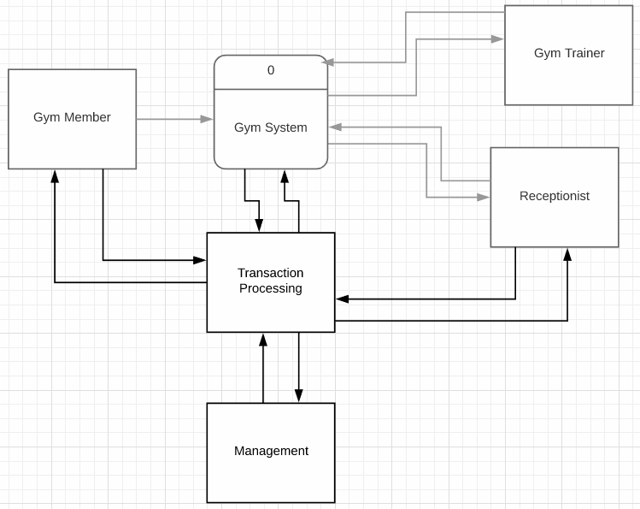

**Level 0 DFD:**

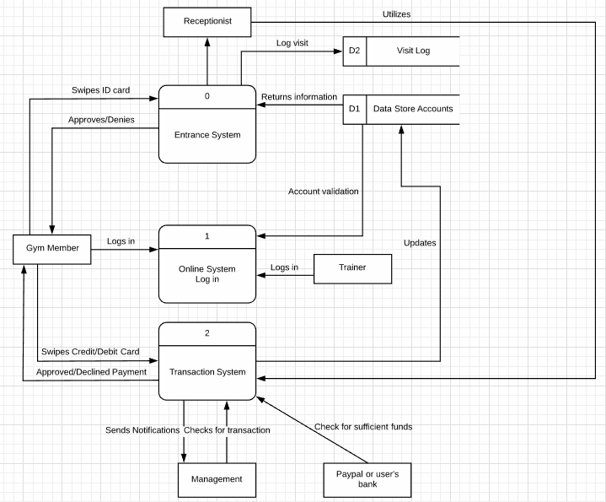

**Level 1 DFD:**

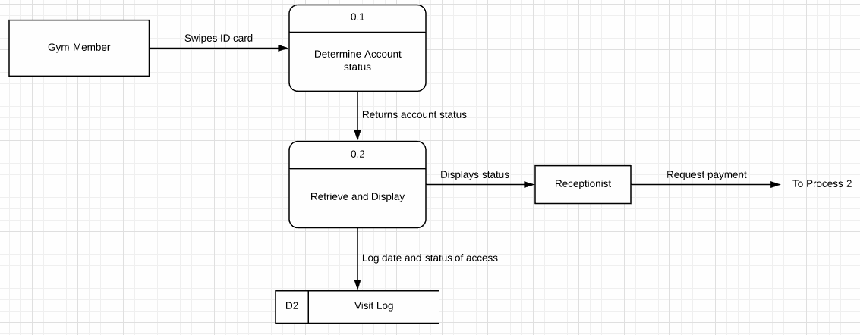

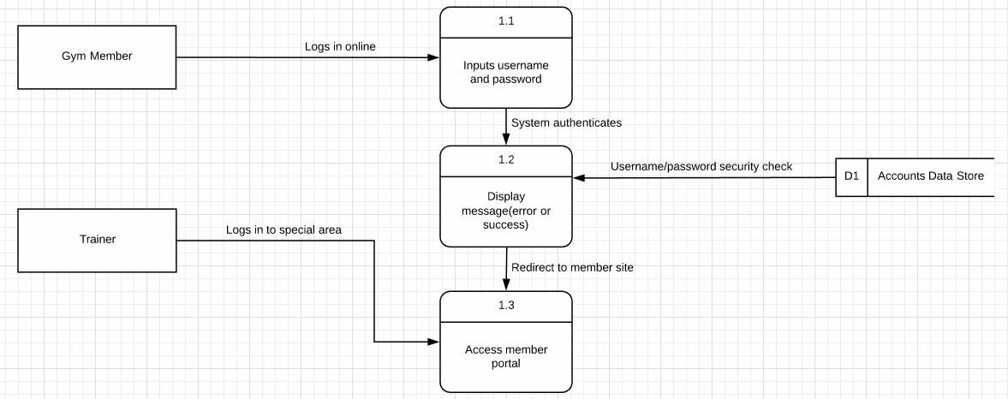

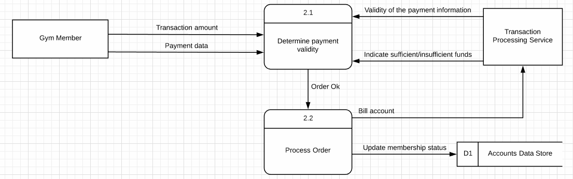

**LEVEL 2 DFD:**

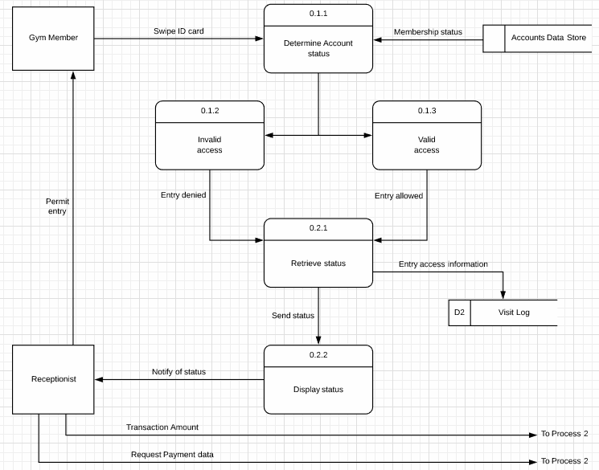

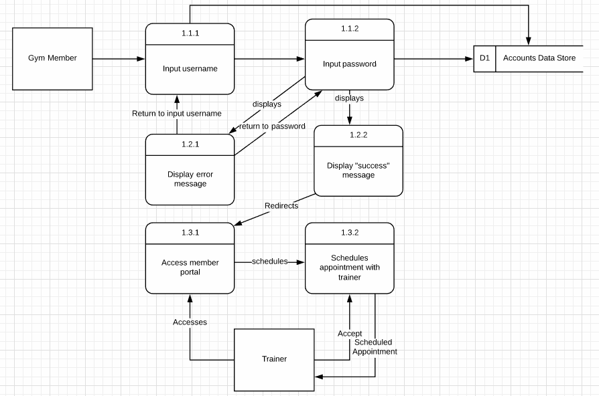

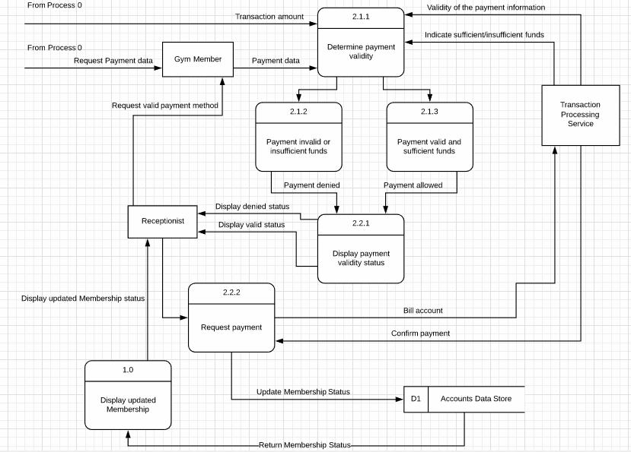

# Section III - Revised Use Cases

# 

# 

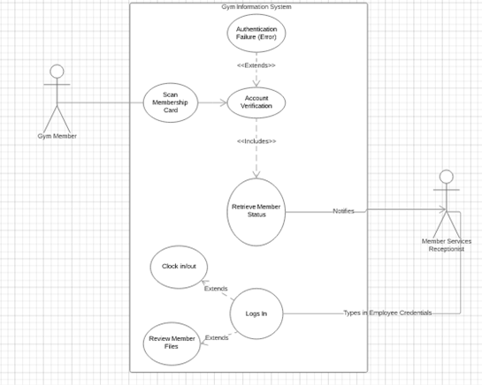

# Section IV - DFD Defined Attributes

|  |  |
| --- | --- |
| **Syntax** | **Definitions** |
| Processes | 0 Entrance System {  This is where member swipes ID card for entry  WHEN cardSwipe THEN  Transmit Credentials  }  1 Online System Login {  This is where member accesses online system  if(username != NULL || password != NULL)  send credentials to verify  Retrieve Profile  else  Return no_data_found  }  2 Transaction System {  This is where member pays for membership  If(cardExpired = true || cardInvalid = true)  Return error  Else  send card to TPS  }  0.1 Determine Account Status {  Verify membership status  Send information to data flow 0.1.2 and 0.1.3  Invalid access = Entry denied  Valid access = Entry allowed  }  0.2 Retrieve and Display {  Retrieve data flow information from 0.1  Logs visit  Sends data flow to 0.2.2 to display status to receptionist  }  1.3 Access Member Portal {  Allows member to schedule appointment with trainer  Allows trainer to accept scheduled appointments  }  2.1 Determine Payment Validity {  Retrieves data flow information from process 0, gym member, and transaction processing service  Sends data flow to 2.1.2 and 2.1.3  Sufficient funds = payment allowed  Insufficient funds = payment denied  }  2.2 Process Order {  Retrieves data flow information from 2.1.2 and 2.1.3  Displays and sends data flow to Receptionist with valid or invalid status of payment  } |
| Data Flows | Data Store Info  D1 to 0  Information from Data Store  ID Card  Gym Member to 0  Unique integer derived from barcode on ID card  ID Approval/Denial  0 to Gym Member  Validation response from Entrance System  Member Login  Gym Member to 1  Credentials for member online account including ID and Password  Credit/Debit Card  Gym Member to 2  Card Number, Expiration Date, Security Code, Card Holder Name, Billing Address, Zipcode  Pay Approval/Denial  2 to Gym Member  Validation response from Transaction System  Updates  2 to D1  Transaction information from Transaction System including bills, payments, and statements  Account Validation  D1 to 1  Validation response from Data Store Accounts  Trainer Login  Trainer to 1  Credentials for trainer online account including ID and Password  Notifications  2 to Management  Notification messages from Transaction System  Check  Management to 2  Message Received Confirmation from Management  Sufficient Funds Check  Paypal or user’s bank to 2  Inquiry from outside source to Transaction System  Visit Log  0.2 to D2  Log of information generated by Entrance System  Schedule  1.3.1 to 1.3.2 to Trainer  Schedule information and requests  Schedule Acceptance  Trainer to 1.3.2  Response to Request from 1.3.2 |
| Data Stores | D1 Data Store Accounts -  (*Insert Definition Here*){  D2 Visit Log -  (*Insert Definition Here*) {  *Detail Here*  }  D3 Transaction {  *Detail Here*  } |
| External Entities | **Gym Member**  Type: External Entity  Description: Member who goes to gym, has ID card  Input Data Flows: Approved/Declined Payment, Approves/Denies ID Card  Output Data Flows: Swipes ID Card, Logs in, Swipes Credit/Debit Card  **Receptionist**  Type: External Entity  Description: In charge of physical check in/check out of gym members, logs each visit  Input Data Flows: Displays/notifies status  Output Data Flows: Utilizes transaction system, requests payment, allows access  **Personal Trainer**  Type: External Entity  Description: Trainer that can be assigned to gym member via online appointment. Trainer would log in to member area of system.  Input data flows: schedules appointment  Output data flows: accepts appointment, logs in/accesses  **Transaction Processing**  Type: External Entity  Description: Consists of bank or Paypal.  Input data flows: Swipe debit/credit card, Bill account, check for sufficient funds  Output data flows: Validate funds(sufficient/insufficient). Validate payment  **Management**  Type: External Entity  Description: Owners of gym  Input data flows: Sends notifications  Output data flow: Checks for transaction |